|  |  |
| --- | --- |
| Date | 5 november 2022 |
| Team ID | PNT2022TMID14925 |
| Project Name | Signs with smart connectivity for better road safety |

**Use Dashboard Nodes For Creating UI(Web App)**

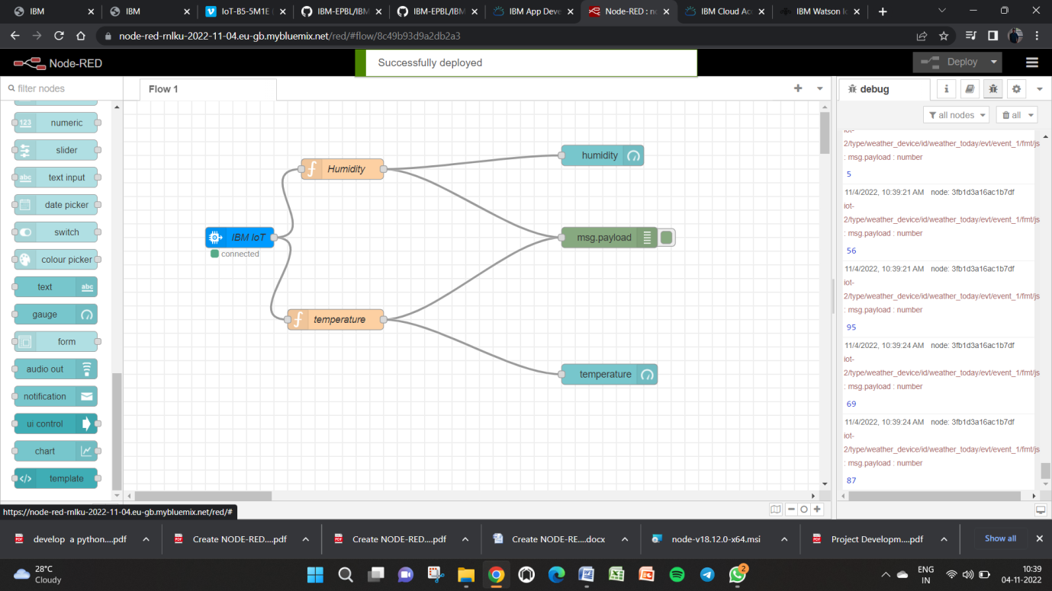

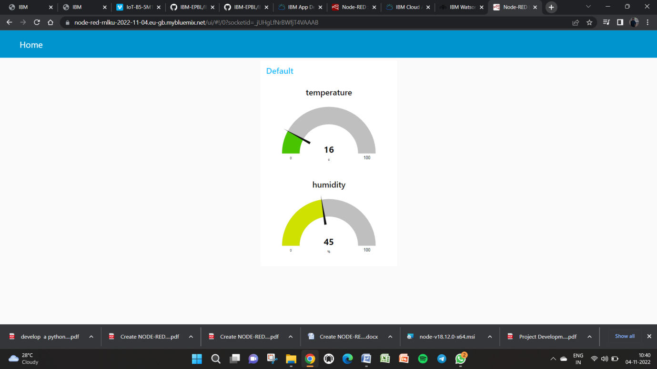

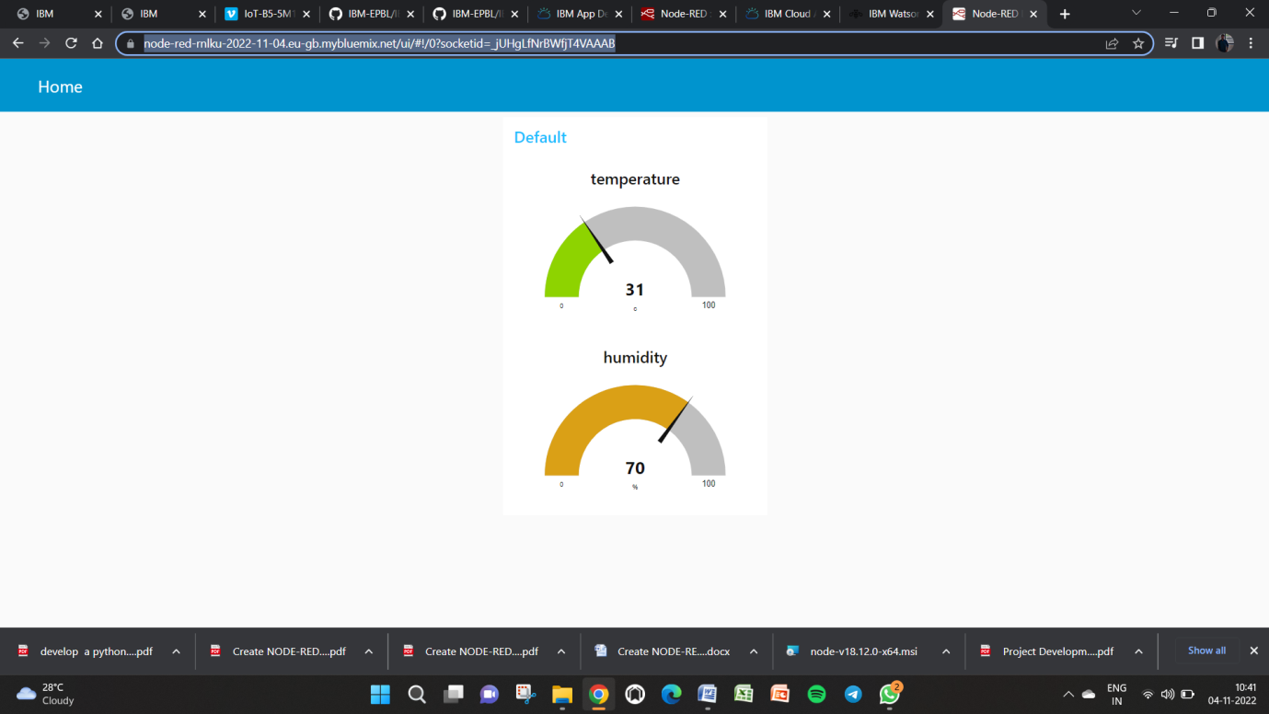

url for device:

[https://node-red-rnlku-2022-11-04.eu-gb.mybluemix.net/ui/#!/0?socketid=\_jUHgLfNrBWfjT4VAAAB](https://node-red-rnlku-2022-11-04.eu-gb.mybluemix.net/ui/" \l "!/0?socketid=_jUHgLfNrBWfjT4VAAAB)